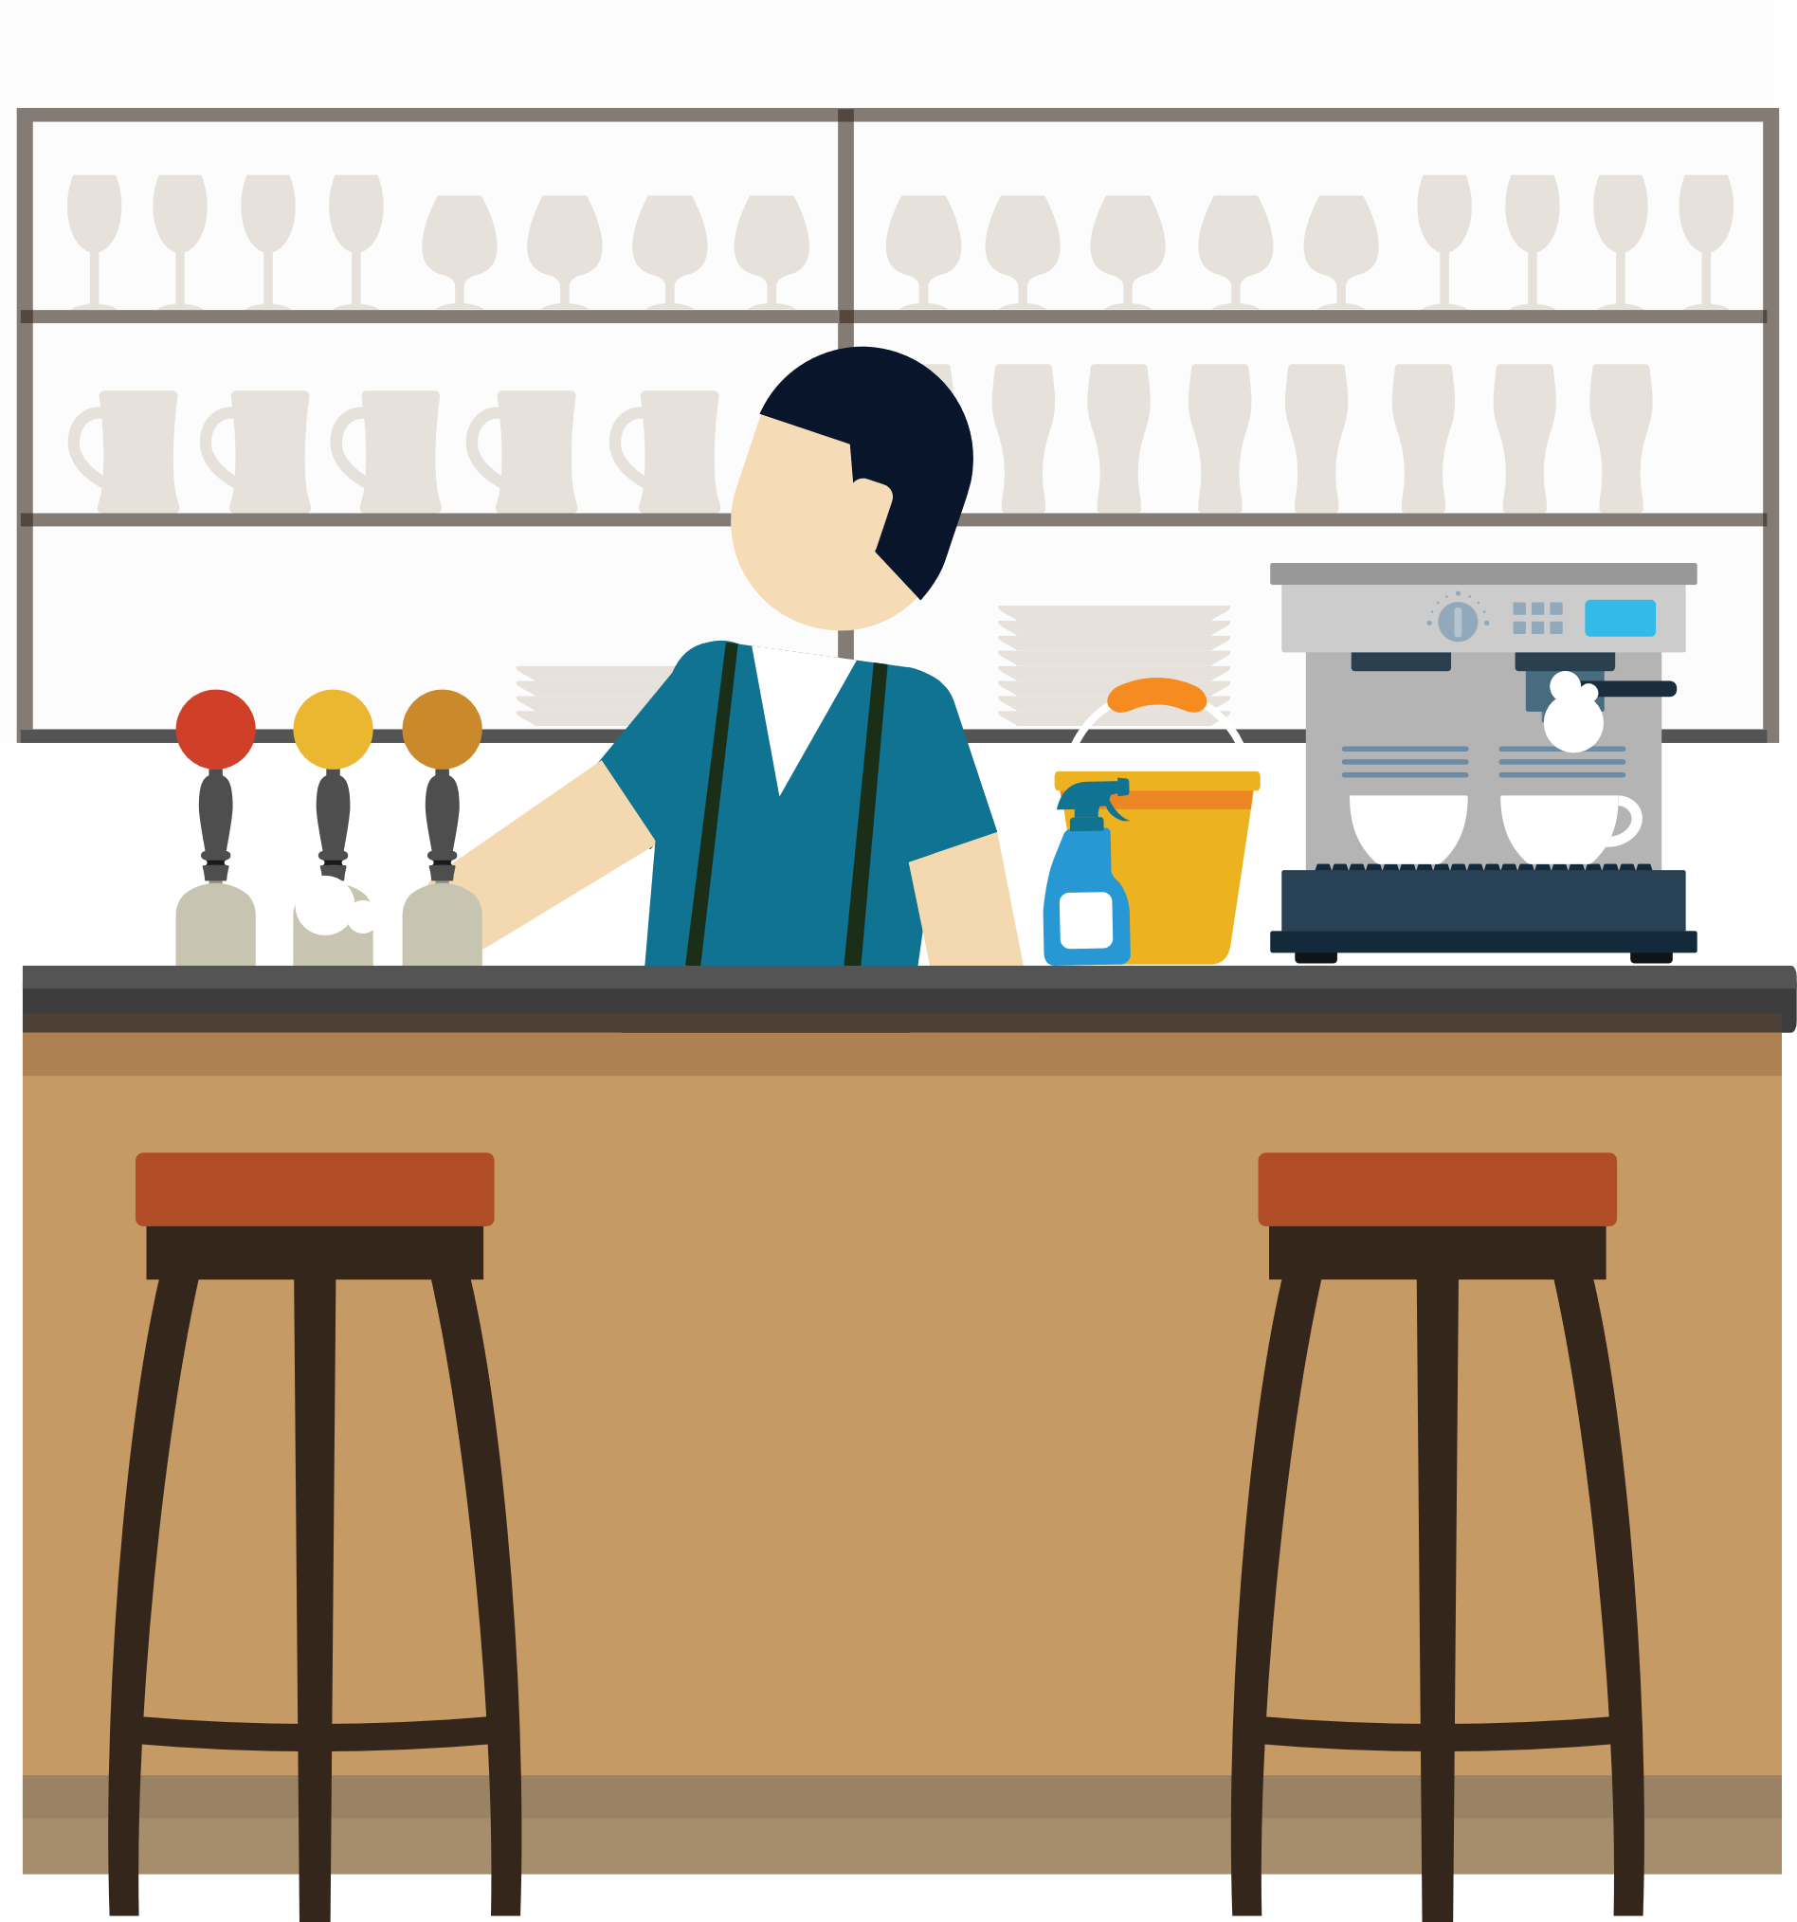
Checklist for reopening terraces
May 2021

Name catering business Click or tap here to enter text.

Completion date of checklist Click or tap here to enter text.

Completed by Click or tap here to enter text.

 | OK | Not OK | Remarks
Material
Place the tables in such a way that a maximum of 4 people can sit at one table. An exception applies only to families of more than 4. | ☐ | ☐
Provide a distance of at least 1.5 meters between the chairs of each table group. Advice: Use markers on the floor such as circles or squares. | ☐ | ☐
Only provide seats at the table. Standing tables and places are not allowed. | ☐ | ☐
Provide marking to split incoming and outgoing flows of customers.  Advice: if 1.5m cannot be guaranteed, provide plexiglass screens. | ☐ | ☐
Provide alcohol gel for customers when entering the terrace and building. | ☐ | ☐
The staff can dispose of alcohol gel or wash their hands with soap and water. | ☐ | ☐
Provide soap, paper towels and a waste bin in the toilets.  Advice: hand blowers must be put on non-active. | ☐ | ☐
A terrace may only be partially sheltered. It must be open on at least one full side without any hindrance, regardless of weather conditions. | ☐ | ☐
Provide adequate ventilation in all indoor areas where personnel work.  Advice: open as many doors and windows as possible, and lock them where possible. Put the cooker hood on. | ☐ | ☐
Avoid publicly shared items (menus, salt and pepper shakers, olive oil ...) or clean them after each use (e.g. pin machine). | ☐ | ☐

 | OK | Not OK | Remarks
Organisational measures
Your staff always wear a surgical mouth mask. | ☐ | ☐
Mark the places / tables yourself and avoid confusion. For example, place a sign "We will accompany you to your table". | ☐ | ☐
Clean tables and chairs between shifts. | ☐ | ☐
Provide a cleaning plan with regard to cleaning the sanitary facilities: who, what, with what frequency, with which products. | ☐ | ☐
The staff should regularly disinfect their hands with soap and water or alcohol gel. At the start of a shift it is best to wash hands with soap and water.  Advice: use hand alcohol gel after accepting cash or after clearing used plates, cutlery and glasses. | ☐ | ☐
The maximum sound level of the music is limited to 80 db. | ☐ | ☐
Only ordering and serving at the tables is allowed. | ☐ | ☐
The customer may only enter the interior space to use the sanitary facilities, to go to and from the terrace or to pay. | ☐ | ☐
Opening hours are limited from 8 am until 10 pm. | ☐ | ☐
The staff applies a strict delineation of tables or tasks (either cleaning and clearing, or serving, or kitchen work). | ☐ | ☐
Present employees are registered monthly via the social security website. | ☐ | ☐
Avoid legionella contamination at start-up by performing a flushing program in which all cold water taps or pipes are rinsed.  Advice: consult our informational document about legionella. | ☐ | ☐

 | OK | Not OK | Remarks
Instructions for personnel and customers
Provide informative posters for customers and display them clearly visible on the terrace:  - disinfection of hands upon arrival is mandatory;  - it is mandatory to wear a mouth mask when a customer is not sitting at the table (from 12 years);  - customers are only allowed to leave the table to go to the toilet or to pay;  - The general applicable measures also apply when sitting on the terrace. | ☐ | ☐
Provide an instruction in the toilets that hand washing is mandatory.  Advice: print our 10 steps for effective hand hygiene and put it on the wall in the toilets. | ☐ | ☐
Provide an instruction for your staff with the most important guidelines:  - wearing a surgical mouth mask is mandatory;  Advice: wear the mouth mask over the mouth and nose, a plastic mouth mask, scarf or bandana is not allowed. A faceshield should not replace a mouth mask unless for medical reasons. Consult our poster on mask use.  - hands must be disinfected regularly. | ☐ | ☐

More information about a safe and healthy start-up in the catering industry?

Any questions? Contact your company visitor. The contact details can be found in MyMensura.

Questions about testing in the workplace?
More info on our blog.

> Consult our sector specific guide on mensura.be

> Go to our blog
> Go to MyMensura

This document was prepared on 03/05/2021 on the basis of the measures in force on that date.

